**Polarity**

* Polar molecules contain a dipole, non-polar molecules do not
* A dipole is two partial oppositely charged poles existing within the molecule
* Polarity is the unequal share of valence electrons between covalently-bonded atoms (polar covalent bonding)

e.g. HCl

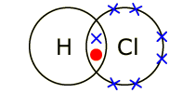

* Chlorine has more valence electrons than hydrogen, and since electrons are negatively charged, chlorine has a partial negative charge compared to hydrogen, which has a partial positive charge relative to chlorine, as negative charge cannot exist without positive charge
* Because chlorine has a greater share of valence electrons than hydrogen, chlorine ‘pulls’ hydrogen’s electrons to it; this is polar covalent bonding
* HCl contains a partial positive charge pole and a partial negative charge pole; a dipole, therefore HCl is a polar molecule (with polar covalent bonding)
* Non-polar molecules can contain polar covalent bonding

e.g. CO2

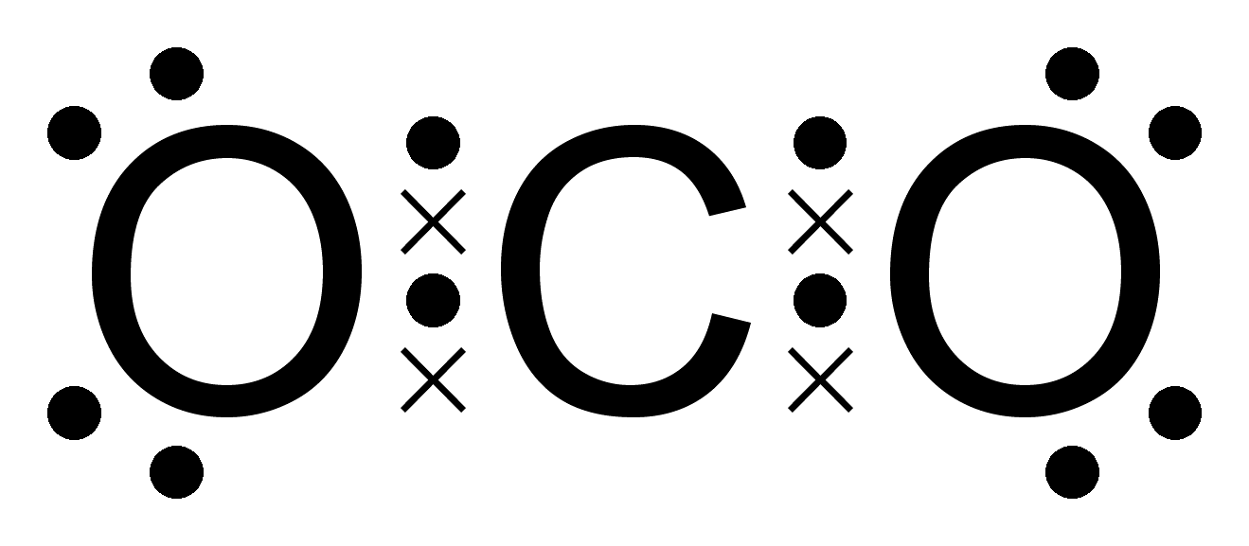

* Polar covalent bonding exists within this molecule as the two oxygen atoms have unequal shares of valence electrons compared to carbon, therefore the two oxygen atoms have partial negative charges, and carbon would have a partial positive charge
* Since both oxygen atoms have a partial negative charge compared to carbon, they are both ‘pulling’ on carbon’s electrons in opposite directions
* Since both ‘ends’ of this molecule have a partial negative charge, no dipole is formed, therefore CO2 is a non-polar molecule (with polar covalent bonding)

**Intermolecular Forces (IFs)**

* IFs are the forces between molecules, not within them
* Strength of IFs from weakest to strongest goes: dispersion forces (DFs) > dipole-dipole forces (DDFs) >

H-bonding > ion-dipole forces

* DFs exist between all molecules, and strengthen with increasing molecular weight, a molecule’s length, and its structure & shape
* Molecular weight and length affect the strength of DFs because it affects how ‘tightly packed’ the molecules get, this ‘packing’ of the molecules is the strength of the DFs
* Structure affects DFs through how each molecule interacts with each other, e.g. linear molecules have stronger DFs than spherical molecules as linear molecules ‘slot’ into each other, and become more tightly packed, while spherical molecules interact with each other less, as there is more negative space between them, therefore they can’t ‘pack’ as well and the DFs between them are weaker
* Double bonds weaken DFs as they create ‘kinks’ in the molecules, so the molecules cannot ‘slot’ into each other as effectively, thus, the DFs are weakened
* DDFs exist between polar molecules, and are the polar attraction between an atom with a partial negative charge in one molecule and an atom with a partial positive charge in another molecule

e.g. DDFs between HCl molecules

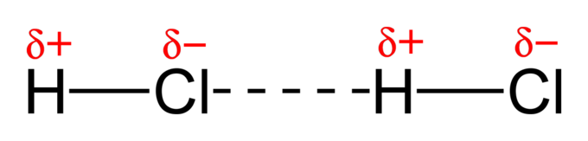

* H-bonding is a much stronger form of DDFs
* It can only occur when hydrogen is bonded to a nitrogen, oxygen, or fluorine atom
* The strength of a molecule’s IFs affect when a state change will occur, as more energy (heat) is needed to break the IFs between the molecules

**Functional Groups**

* Hydroxyl (suffix: –ol), R–OH



* Aldehyde (suffix: -al), R–CHO



* Carbonyl (suffix: –one), R–CO



* Carboxyl (suffix: –oic acid), R–COOH



* Ester (suffix: –yl (for the reacted alcohol) and –oate (for the reacted carboxylic acid)), R–COO–R



* Primary Amine (suffix: –amine), R–NH2



* Primary Amide (suffix: –amide), R–CONH–R



* Note: R means ‘side chain,’ and indicates any possible molecule
* Hydroxyl containing molecules are named ‘alcohols’
* Carboxyl containing molecules are named ‘carboxylic acids’
* Carbonyl containing molecules (with two side chains bonded to the central carbon) are named ‘ketones’
* Polarities of the above groups in descending order: Amide > Carboxyl > Hydroxyl > Carbonyl = Aldehyde > Amine > Ester (Dimerises, H-bonds, DDFs)
* Primary alcohols have one side chain connected to the carbon that the hydroxyl is bonded to
* Secondary alcohols have two side chain connected to the carbon that the hydroxyl is bonded to
* This trend continues for tertiary alcohols

**Simple Physical Properties**

* The solubility of a molecule depends on its IFs; polar molecules dissolve in polar solvents, and non-polar molecules dissolve in non-polar solvents
* Polarity is not black-and-white; sections of a molecule can have H-bonding, while another can have DFs; the polarity of a molecule is defined by its functional groups and chain lengths
* The dissolution of a substance works through a solvent forming IFs between itself and the solute that are stronger than the IFs experienced in the solute-solute IFs (this is why H2O (H-bonding) is a great solvent)
* The functional groups of a molecule affect how many polar connections between two different molecules there can be
* Increasing chain length strengthens DFs, and therefore solubility in non-polar solvents
* The strength of the IFs between the molecules determine the properties such as strength, rigidity, plasticity, malleability, etc.

**Addition Reactions**

* Alkenes are hydrocarbons containing a double bond, they are said to be ‘unsaturated’
* Alkenes undergo addition reactions to break this double bond form saturated alkanes, these alkanes are the only product formed
* Hydrogenation (Alkene + H2 –> Alkane)

e.g. Ethene + H2 –> Ethane

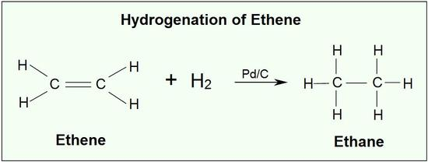

* Halogenation (Alkene + Halogen –> 1, 2-Haloalkane)

e.g. Ethene + Cl2 –> 1, 2-Dichloroethane

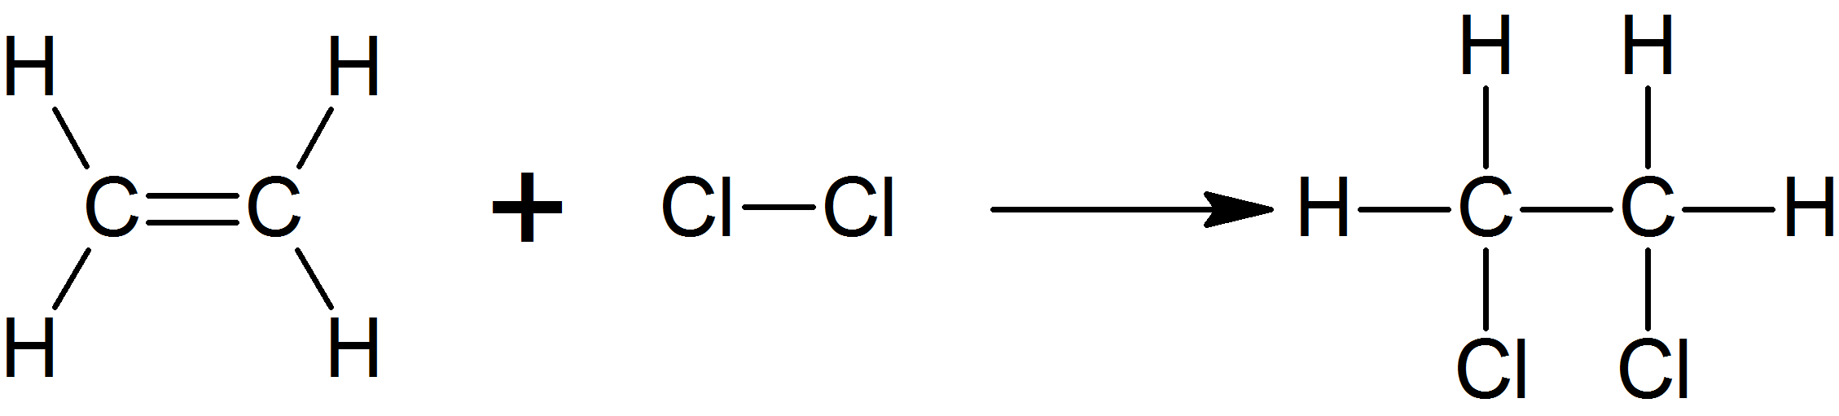

* Hydrogen Halogenation (Alkene + Halogen Halide –> 1-Haloalkane)

e.g. Ethene + HCl –> Chloroethane



* Hydration (Alkene + H2O –> Alcohol)

e.g. Ethene + H2O –> Ethanol



* Addition polymerisations are where many alkenes react with one another to form one long chain

e.g. the polymerisation of ethene to polyethene

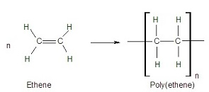

* The above ‘bracket notation’ for the polyethene is the shorthand notation for writing the structure of a polymer, by showing its smallest unit; a monomer
* Polymerisation occurs under high pressure and temperature in the presence of a catalyst
* Polymerisation only starts when a pure substance of the monomer is reacted with itself
* Polymerisation is stopped through an ‘inhibitor;’ a substance that will more readily react with the monomer than the reaction of the monomer with itself

**Advanced Reactions**

* Redox reactions of organic molecules usually change a molecule’s functional groups to new ones
* Primary alcohols are oxidised to aldehydes, these can be oxidised again to carboxyls
* Secondary alcohols are oxidised to ketones
* Tertiary alcohols cannot be oxidised, as the oxidation of alcohols breaks CH bonds and forms new CO bonds, and since tertiary alcohols have carbons that are bonded to no other H atoms, no CH bonds can be broken and thus, oxidation cannot occur
* Esterification reactions are the reaction of a carboxylic acid and an alcohol to produce an ester
* H2O as a constituent of the two reactants is dehydrated from the final product of the carboxylic acid-alcohol addition

e.g. Ethanoic acid + Ethanol –> Ethylethanoate + H2O



* Esterifications are a type of condensation reaction, as water (a small molecule) is a by-product
* The purpose of H2SO4 in an esterification is to heat up the reaction (increase reaction rate) and to act as a dehydrating agent (to remove the water)
* The hydrolysis of an ester is the reverse reaction of an esterification, where a carboxylic acid and an alcohol are produced
* 1-Haloalkanes can be reacted with a base to from an alcohol in a substitution reaction

**Properties of Polymers**

* The properties of a polymer are primarily determined by the properties of its monomers, but also by its length, the extent of its branching chains, and the presence of cross-linking between the polymers
* As chain length increases, DFs grow stronger, creating harder and more rigid materials
* Branching occurs when monomers don’t form a single linear molecule, and smaller ‘branch chains’ bond to the side chains of the polymer
* The extent and nature of the branching in a polymer can weaken the substance’s IFs, as there is an increased distance between the ‘backbone chains’ because of the branches; this makes the material less dense and more flexible
* Cross-linking is the covalent bonding between polymer molecules (usually through a disulphide intermediate)
* Polymers with no cross-linking are said to be ‘thermoplastic’

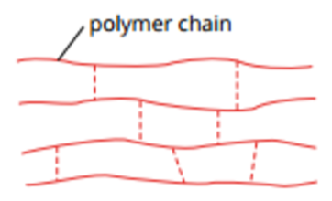

* Polymers with cross-linking are said to be ‘thermosetting’

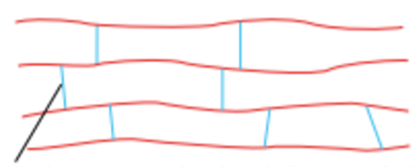

* Thermosetting polymers cannot become a liquid, as the cross-linking bonds require the same amount of energy to break as the actual bonds within the polymer themselves (this makes these materials extremely strong and rigid, as they cannot be softened)
* This means thermosetting polymers cannot melt, so they instead decompose or burn when heated
* Elastomers are polymers containing only occasional cross-linking

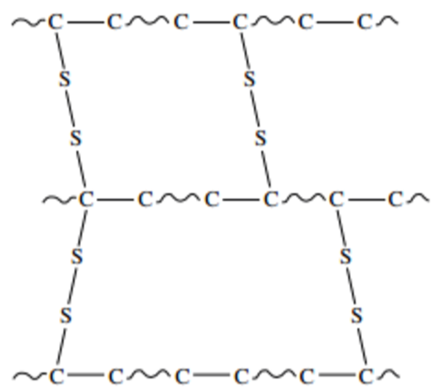

* Elastomers can be easily stretched, as the polymer molecules can still move past each other
* The physical properties of polymers (such as strength, flexibility, rigidity, etc.) are achieved by altering the IFs present through the properties of the monomers or through cross-linking

**Condensation Polymerisation**

* Condensation polymers are formed through the condensation reactions of many molecules of two distinct monomers, each with different functional groups on both ends of the molecule that react chemically with neighbouring monomers
* These two monomers can have any possible molecule between their functional groups, as opposed to addition polymerisations which are limited to unsaturated alkenes, leading to more complex materials
* Ester polymerisations are a form of condensation polymerisation where two monomers (a diol and a dicarboxylic acid) react to produce a single polymer where the original ‘internal monomers’ (sans the functional groups) are linked through the esters produced; the product of this reaction is called a ‘polyester’

e.g. 1, 4-benzenedicarboxylic acid + ethane-1, 2-diol –> polymer + H2O

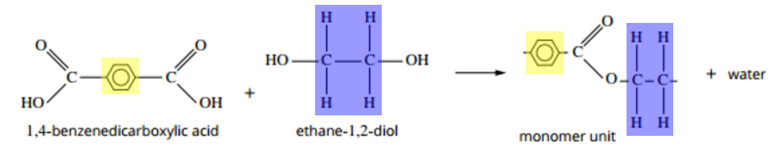

* While two different molecules can be used for condensation polymerisation, single monomers with chemically reactive and different functional groups on each end can polymerise with each other
* ‘Polyamides’ are another class of condensation polymer, formed through the reaction of a dicarboxylic acid monomer and a diamine monomer to produce a polymer where the internal monomers are linked through amides

e.g. 1, 4-benzenedicarboxylic acid + 1, 4-diaminobenzene –> polymer + H2O

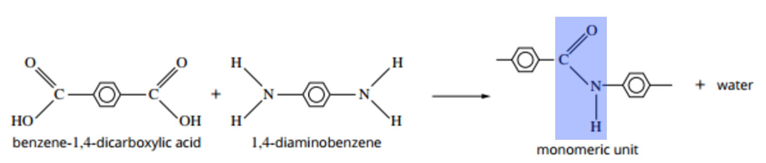

* Polyamides are stronger than polyesters because the IFs found in polyamides are H-bonding while polyesters contain weak DDFs

**Fats and Oils**

* There are two types of fats: saturated (animal fats) and unsaturated (vegetable oils)
* Fats and oils are molecules known as triglycerides, the product of a triesterificiation condensation reaction between glycerol and three fatty acids
* The difference between fats and oils is that fat is solid at STP, while oil is a liquid
* There are three types of fatty acids: saturated (animals), monounsaturated (vegetables), and polyunsaturated (fish and vegetables) fatty acids
* Stearic acid (most-common saturated fatty acid): CH3(CH2)16COOH
* Oleic acid (most-common monounsaturated fatty acid): CH3(CH2)7CH=CH(CH2)7COOH
* Linoleic acid (most-common polyunsaturated fatty acid): CH3(CH2)4CH=CHCH2CH=CH(CH2)7COOH
* Triglycerides can have any different combination of the three fatty acid types in them

**Soaps**

* Saponification is the specific term for the base hydrolysis reaction of an ester, which produces a carboxylate anion and an alcohol
* Saponification of triglycerides destroys the esters present through the use of a strong base to produce glycerol and a fatty acid anion (with an anionic, polar carboxylate ‘head,’ and a long, non-polar ‘tail’)

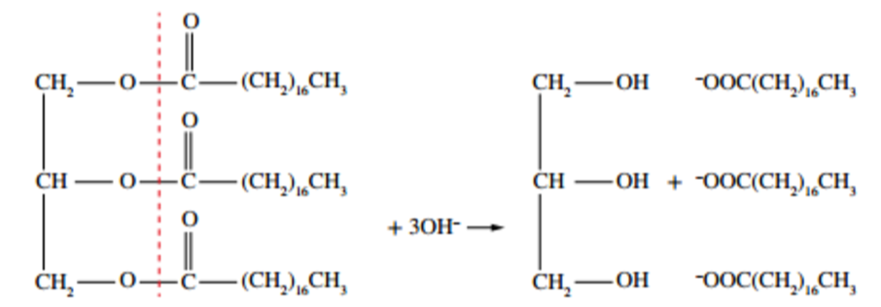

* This fatty acid anion combines with the strong base’s metal cation to form the ‘soap’

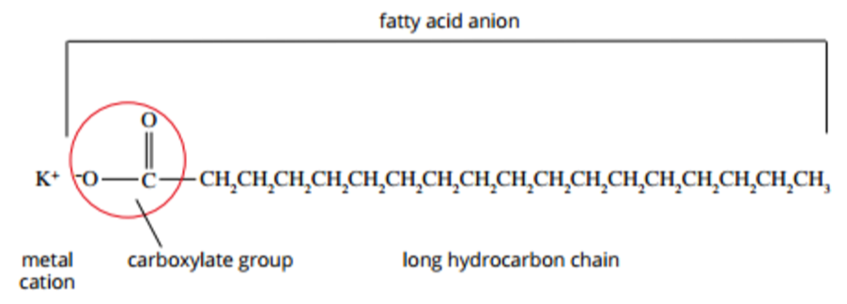

* Detergents are similar to soaps but instead are made from fossil fuels, and still contain the active constituent of soap– a negatively charged species, along with a non-polar tail
* In water, soap molecules come together to form spherical clumps known as ‘micelles,’ where the hydrophilic heads are on the outside, in contact with water, due to their strong attraction to the highly-polarised H2O molecule, where they form strong ion-dipole IFs; the hydrophobic tail chains on the other hand are in the centre of the clump in contact with each other, because they are non-polar, so they try to have as little contact with the polarised water as possible
* The metal cation is a spectator in the cleaning process

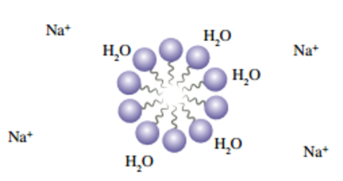

* During cleaning with soap, agitation breaks up the micelles into the individual anions, where the non-polar tails readily make contact with something like oil or grease due to them both being non-polar substances
* As more carboxylates form around something like oil or grease, the hydrophilic heads are exposed to water, which attract each other, and the non-polar substance that needs to be cleaned is lifted away due to the strong attractions between the hydrophilic heads and H2O, while the non-polar tails have kept it in place
* When the non-polar substance is lifted away, a new micelle forms around it as the hydrophobic tails embed themselves in the oil or grease, and the charged heads form ion-dipole bonds with the water, preventing whatever was just cleaned from returning back into the water

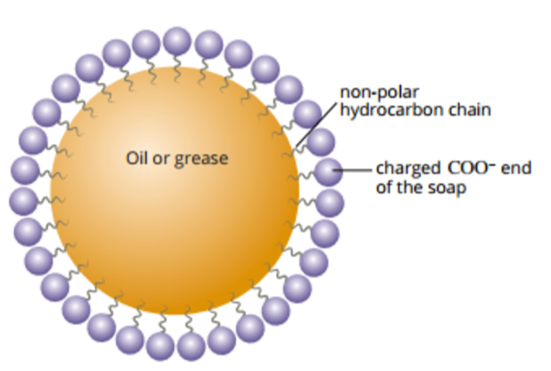

**Biodiesel**

* Biodiesel is a biological fuel source made from the transesterification of triglycerides
* Transesterification reactions changes existing esters into ‘new esters’ by reacting them with alcohols (in the case of biodiesel from a glycerol-fatty acid ester to methanol-fatty acid ester)
* The transesterification of a triglyceride with three methanol molecules produces glycerol and three fatty acid methyl esters (biodiesel)

**Amino Acids**

* Amino acids are the biomonomers that make up the proteins essential to life
* A protein is a biopolymer
* There are only 20 amino acids used to make every protein in a human body
* Every amino acid has an amino group (blue), a carboxyl group (red), and a hydrogen attached to the central carbon (green), with a side chain also attached to this central carbon
* The ‘central carbon’ is known as the α-carbon (alpha-carbon)

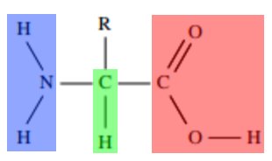

* Amino acids with an alpha-carbon are known as α-amino acids
* An alpha-carbon has both the amino group and the carboxyl group bonded to it
* Amino acids are abbreviated with three letters
* The differences between the amino acids come from the properties of their side groups, which could be polar, non-polar, proton donor, proton acceptor, etc.
* Within humans, 11 of the 20 amino acids needed for all proteins are synthesised in the body, these are known as the non-essential amino acids
* The 9 amino acids that can’t be synthesised in humans are known as the essential amino acids and must be obtained through proteins in the food we eat, which are broken down into said essential amino acids
* The essential amino acids are from Ile to Val in the data booklet (along with His, but only in infants)
* The functional groups of the amino acids in aqueous solution can act as an acid and a base, the amino group accepting a proton to become NH3+, and the carboxyl group donating a proton to become COO-
* This simultaneous positive and negative charge on the amino acid is called a zwitterion

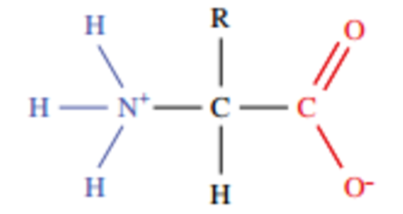

* A zwitterion is a molecule that contains a positive and a negative charge but no overall charge
* The dual acidic-basic nature of amino acids means different chemical forms can be found at equilibrium, depending on the pH level of the solution
* The zwitterion, present at pH 5-7: +H3N–CH(R)–COO-
* Cationic amino acids are the most abundant form at a pH of 0-5: +H3N–CH(R)–COOH
* This is because the excess H3O+ ions in solution react with the proton accepting carboxylate group, reforming the carboxyl and leaving the solution with a net positive charge from the NH3+ ion
* Anionic amino acids are the most abundant form at a pH of 7-14: H2N–CH(R)–COO-
* This is because the NH3+ group donates its protons to the excess OH- ions in solution to reform the amino group, leaving the solution with a net negative charge from the COO- ion
* The dynamic equilibrium reaction for the chemical change of the zwitterion to a cationic or anionic form can be written as: +H3N–CH(R)–COO- + H3O+/ OH- **⇌** +H3N–CH(R)–COOH/ H2N–CH(R)–COO- + H2O
* In low or high pH levels, the equilibrium shifts well to the right for this equation
* If the side chain of the amino acid has acid-base properties, it is possible for other charged forms of amino acid to form

**Protein Formation**

* α-amino acids contain both an amino and a carboxyl group, which means they can react with one another in a condensation reaction
* When two amino acids react, an amide group is formed that links the molecules together
* The amide link in biochemistry is referred to as a peptide link
* The bond between the carbon and the nitrogen in the peptide link is known as a peptide bond
* When two amino acids react together, the product is called a dipeptide

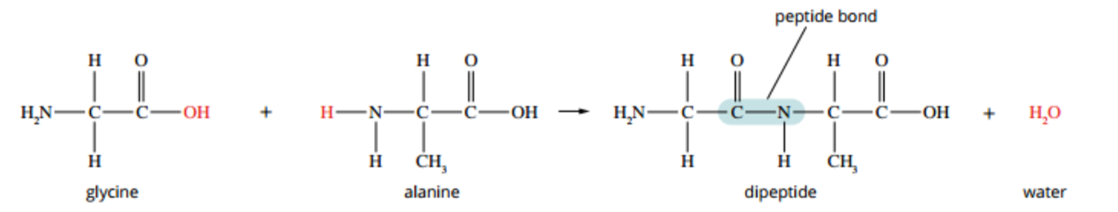

* Each time a pair of different amino acids react with one another, two possible products can be formed, depending on which functional groups in each molecule reacted together
* Tripeptides are the products formed from the condensation reaction of three amino acids
* Polypeptides are the polymers formed by the condensation polymerisations of amino acids
* In a polypeptide, the amino acid that has a free (unreacted) amino group is referred to as the N-terminal amino acid
* Likewise, the amino acid that has a free carboxyl group is referred to as the C-terminal amino acid
* Polypeptides are named sequentially from left-to-right for each amino acid from the N-terminal to the C-terminal, using the three-letter abbreviations of the amino acids
* A polypeptide constructed from fifty amino acids or more is usually referred to as a protein
* Being very large molecules, proteins have a complex three-dimensional structure
* As polypeptides are formed from condensation reactions, your body needs water to reverse these reactions in a hydrolysis and breakdown the proteins in the food you eat into amino acids needed for new protein formation

**Primary and Secondary Structures of Proteins**

* Proteins differ from one another in the number, type, and sequence of their constituent amino acids
* The number, type, and sequence of the amino acid units in a protein is known as the protein’s primary structure
* The primary structure may be represented by the three-letter abbreviations of the amino acids (starting from the N-terminal and going to the C-terminal) or by the structural formula of the protein
* The three-dimensional structure of the protein is determined by the precise order of the amino acids, as the many interactions between these amino acids cause the protein to fold into two different structures
* Coiling and pleating of the proteins produces the secondary structure
* The secondary structure is formed due to H-bonding between the –NH group in one peptide link and the –C=O group in another peptide link at regular intervals
* This H-bonding creates regions where the protein coils into a spiral shape, known as an α-helix, or where sections of the protein line up parallel to each other, forming a β-pleated sheet
* These ordered segments, stabilised though H-bonding, are referred to as the protein’s secondary structure
* The α-helix is formed from the H-bonding between the partial positive charge of the hydrogen on the –NH group and the partial negative charge of the oxygen on a –C=O group four amino acid units away
* These sequential H-bonds coil the protein chain so that each H-bonding digroup is perpendicular to one another

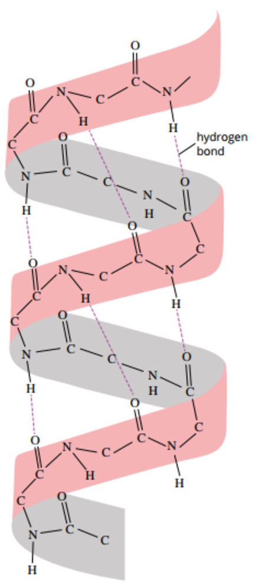

* Some amino acids are more or less likely to coil into α-helices than others, e.g. Gly and Pro are unlikely to exist as an α-helix because of their structures
* Pro contains a ring in its structure, and because of this it is very unlikely to coil as the ring makes the amino acid too rigid to form part of a helix
* Gly is unlikely to coil as its side chain contains a lone hydrogen, meaning the molecule is very flexible compared to other amino acids and would weaken the stability of an α-helix
* β-pleated sheets form when the protein chain bends on itself so that parallel H-bonding occurs between the peptide links in individual ‘sheets,’ connected through loops that do not H-bond to this structure
* These sheets form due to the repeating structure of the protein’s ‘backbone:’ –C–C–N–, which allows the H-bonding to occur at regular intervals and stabilises the structure

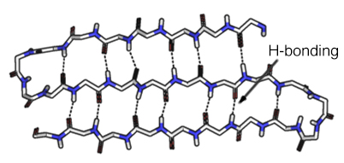

* Protein structure is usually rendered in the third-dimension through ‘ribbon diagrams’
* In a ribbon diagram, the ‘ribbons’ represent α-helices, the ‘arrows’ represent β-pleated sheets, and the ‘tubes’ represent the simple linear protein chains that connects the secondary structures and does not form a structure itself



**Tertiary Structure of Proteins**

* The overall three-dimensional shape adopted by a protein is called its tertiary structure
* The amino side chains, α-helices, and β-pleated sheets fold and twist over themselves to create the protein’s unique structure
* A protein’s unique three-dimensional shape and structure is created to achieve maximum stability and the lowest amount of energy used for the size, properties, sequence of the polypeptide chain(s) present, and the secondary structures present
* A protein’s tertiary structure is closely related to its function
* The amino acid side chains have varying properties and interact with the rest of the molecule to produce the tertiary structure
* Amino side chain properties that influence the shape of the tertiary structure are: its polarity (polar (hydrophilic) side chains will fold to the outside of the protein to be in contact with water molecules while non-polar (hydrophobic) side chains will fold to the interior of the proteins, away from contact with water molecules), the presence of a charge (forms very strong ion-dipole IFs which stabilises the structure; pH dependent), the size of the side chains (larger side chains have strong DFs and will ‘stack’ together for molecular stability), and the side chain’s structure (linear side chains are flexible and good for stability while ring structures are large and unstable)
* Five types of bonding occur in proteins that are important for formation of a stable tertiary structure, they are: H-bonding, DDFs, ion-dipole IFs, covalent cross-linking (disulphide bridging), and DFs
* The conditions in which the protein is present affects the tertiary (and secondary) structure (increasing temperature weakens chemical and intermolecular bonds, and pH affects the charges present in the side chains and terminals (and hence, the ion-dipole forces))
* If the tertiary and secondary structures are compromised, denaturing of the protein occurs, where it completely unfolds into a linear chain